**Implementing improved methods of detecting and care of incurable neurological brain disorders through the use of IoT, Mobile Devices and Website Applications**

Aaron Stones

School of Design and Informatics

Abertay University

DUNDEE, DD1 1HG, UK

**ABSTRACT**

**Context/Background:** Within the United Kingdom it has been widely reported by the media that the NHS or National Health Service has been facing extreme cuts. Problems like ageing populations and overpopulations in hospitals and nursing homes has become a severe problem that cannot be addressed due to these cuts. With this in mind, the NHS (National Health Service) has been unable to update their already out of date systems to coincide with commonly used technology.

**Aim:** With every day technology such as mobile phones and IoT devices being unmissable among almost every United Kingdom citizen, is it possible that these can be used to monitor the health of this ageing population and accurately report back to medical personnel, if assistance is required or if the patient is okay?

**Method:** Within this project both a prototype Android application will be developed and IoT device to attempt to monitor a patient’s condition. In coalition with these forms of technology, a website application will be developed to allow doctors, carers, nurses, etc to ensure patients are receiving appropriate levels of care. These will be developed by a fourth year Bachelor of Science Computing student and managed by a Project Supervisor of a relating field. The decision to utilise these forms of technology has come because of their inexpensive nature, an IoT device is relatively inexpensive to setup and manage, as well as nearly every United Kingdom citizen owning a mobile device.

**Results:** The results that are being looked for with this project is that, these applications and devices can be setup for economical amounts and provide the same results to a medical professional as if medical personnel would be conducting the tests themselves. A positive result would show that patients can be monitored digitally without compromising an already exceptional standard of patient care.

**Conclusion:** This project is worth completing as the National Health Service is at breaking point and is in need of liberating medical professionals time. This project will demonstrate whether the problem of an ageing population can be helped through the use of new, evolving and inexpensive forms of technology. If this project is a success, we could see the start of a technological revolution occurring with the National Health Service.

**Keywords**

**IoT** – Internet of Things.

**Android** – Operating System used on many mobile devices.

**NHS** – National Health Service.

**Palliative Care** – treating people with diseases that cannot be cured.

**CT Scan** – A Computed Tomography scan

`

**1. INTRODUCTION**

Within the United Kingdom right now it is estimated that around 410,000 people live inside ‘Care Homes’ (GOV.UK, 2019). Around 10% of these residents have primary health options, this means the patient is no longer able to look after themselves and have been admitted to residential care to protect them. A following 49% of the residents in ‘Care Homes’ are LA-funded, this is a scheme setup by the United Kingdom government to contribute to a quarter of the living costs for these residents (GOV.UK, 2019).

However, it has been reported within the media recently that due to an ever increasing and ageing population, a need for patients to be admitted due to concerns for their health (primary options) out-ways the need for these forms of care. This is in comparison to residents on LA-funded schemes, who could achieve an equally adequate or even better form of care from their own homes through the use of technology. This technology could be used to manage the different conditions patients may have or used to detect these conditions early.

Within these ‘Care Homes’ many patients are living with both; early and advanced neurological brain conditions and require regular assessment from Nurses and Doctors to assess the progression of their disease and any notable changes. This only happens if a patient has been correctly diagnosed. If Parkinson’s is taken as an example according to WebMD – “It has been estimated that, especially in its early stages, nearly 40% of people with Parkinson’s Disease may not be diagnosed, and as many as 25% are misdiagnosed.” (WebMD, 2019) This shows a lack of ability to accurately detect this conditions and so accurate care cannot be provided. The main means for the detection of degrading neurological conditions is the use of CT scans, which are both time consuming and expensive to public bodies like the NHS (National Health Service), with each scan costing around 609.70 pounds according to costevaluation.com (Costevaluation.com, 2019). This is a necessity to accurately detect neurological conditions, but are in high demand. Mobile Phones and IoT devices could be used to run small tests before hand by the suspected sufferers to give an early prognosis of these conditions where then the CT scan is only a formality to confirm what is already known.

**2. BACKGROUND**

This Project Proposal has been conducted at an Honours level and follows on from comparative work, that has been conducted within the field of using IoT devices and Mobile Phones within elderly care. The problem that is being addressed is overspending, overcrowding and technological neglect within the care of the elderly. Within the care of the elderly two main neurological conditions that predominantly optimize these issues. These are Dementia and Parkinson’s. The way in which these neurological diseases are identified and managed is typically, for detection, through the observation and small memory tests or physical challenges to decide if a patient should be sent for a CT-scan to confirm if they definitely have the disease or diseases. This has led (as previously stated) to the misdiagnosis of the conditions. Management again consists of visual observations, in tandem with medication. Both detection and management involve lots of tests that can be automized before the CT-scan. With the introduction of impressive accelerometers within mobile devices and IoT devices, speakers and game compatibility within these devices it’s not odd to propose that these devices can be used to detect and provide accurate test results.

**2.1 Avoidable hospitalisations**

From the clinical investigation called ‘Residents: Frequency, Causes, and Costs’ conducted by Joseph G. Ouslander, MD,

Gerri Lamb, PhD, RN, FAAN, Mary Perloe, MS, GNP, JoVonn H. Givens, MPH, Linda Kluge, RD, LD, CPHQ,

Tracy Rutland, MBA, MHA, Adam Atherly, PhD,

and Debra Saliba, MD, MPH. This study was conducted in Georgia and describes elderly patients concerns when they are hospitalised. Issues arise in the stress of being moved to the hospital and the associated risks when patients are being transported to hospitals. These transfers are said to have occurred when a patient is feeling unwell, if they are abnormally stressed, if they have had a fall and if any other accident has occurred within their home or a nursing home. The clinical investigation continues to say that these hospitalisations are 67% of the time avoidable and cited on-care facilities and a lack of medical knowledge as the key motivator for the unnecessary hospitalisations (Ouslander, 2010). From this it can be said that, new methods of detecting and managing the elderly and when or if they should be admitted to hospitals. The cost to the Georgian medical association for all of these unnecessary hospitalisations is approximately 142 million dollars (Ouslander, 2010). The clinical investigation stresses a need to redevelopment or reorganisation of the way in which care is provided to the elderly.

**2.2 Re-developments**

As previously stated, the NHS or National Health Service needs to find more cost-effective methods of treating patients, without impeding on the quality of care provided by the NHS.

The inspiration for this proposal comes from Chapter 8 and 9 from the book ‘Stop Saving the NHS and Start Reinventing it’ by Colin Jervis (Jervis, 2013). The book explains how money is being cut from the NHS with Within these chapters it is depicted that there is a need for more use of mobile and IoT devices to monitor the health care of patients. This would be done through a device sending patient data that has been collected through the sensors (blood pressure, test results, any complications, etc) and sent to a server. The server would then display the information to someone with the expertise to be able to understand it and accurately advise. Within these chapters it is also depicted that faster methods of communicating action plans from said results need to be put into place, compared to the out of date method of sending a letter in the post. With mobile devices and IoT devices instant messaging is simple and can be implemented very simply allowing patients to get a response from medical professionals as soon as the data has been analysed by them.

**3. METHOD**

A solution to a similar problem that has been solved has been reviewed. This comes from a paper written by Pierre Gard, Lucie Lalanne, Alexandre Ambourg, David Rousseau, Fran¸cois Lesueur, and Carole Frindel called ‘A Secured Smartphone-Based Architecture for Prolonged Monitoring of Neurological Gait’. This paper has been created to monitor neurological gait by a patient and then report back to a clinician all through a patient’s phone and a server. From this, a graph is produced to show both a patient and the clinician, an accurate view of how the recovery process is coming along as shown in figure 1. A patient would then be able to get updates on what the experts prescribe the next phase in their recovery is (as this is a physio-therapy application the next phase is always new exercises).

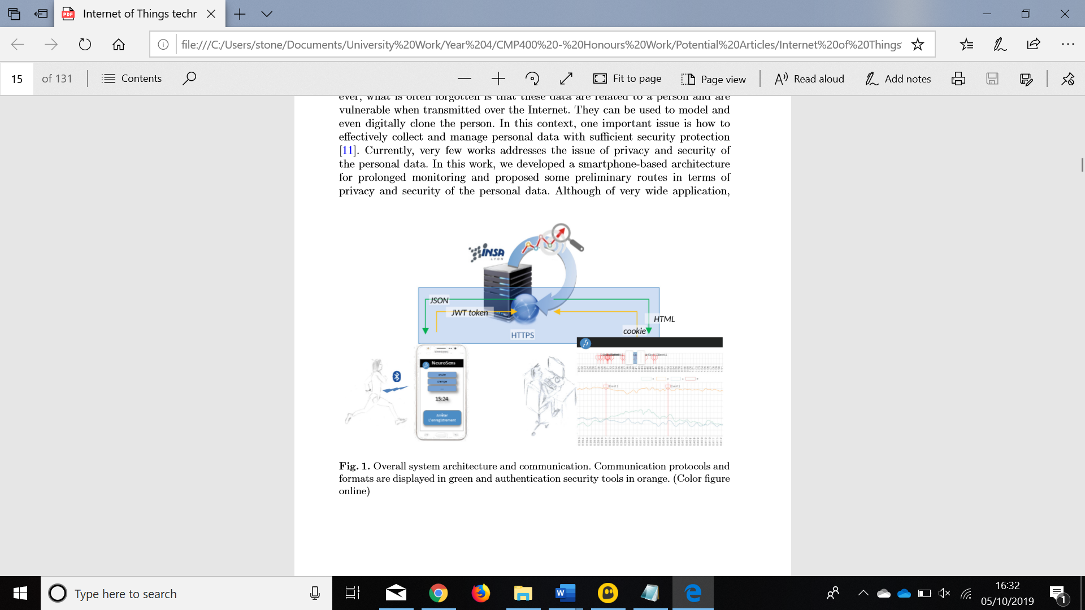

**Figure 1 – An example of the gait monitoring system graph (Gard, 2018)**

From this graph it can be seen that there is no accurate way to track progress as the data is all dumped onto one graph. With the clinician’s application that will be developed a line of best fit will be used to track a patient’s health progress or digression. Similar technologies will be used to analyse a patient’s health (sensors, cameras and tests).

However, a graph with a line of best fit will be used to show the progression, stabilisation or digression of a patient’s medical condition to a medical professional. Another difference is also that this project will be focussing on the detection and management of neurological conditions such as Parkinson’s and Dementia as compared to the neurological gait conditions this article has looked into.

The elderly has been selected as one of the main costs to the NHS because of issues previously described (ageing population, poor management and poor technological systems). A healthcare application, IoT device and website application will be developed and tested to improve the management and healthcare of the elderly so they can fulfil their life, without needing to be hospitalised or unnecessarily being moved into care homes.

During the development of these devices and applications a methodology has to be selected and development practices adhered to. The methodology that has been selected is an Agile methodology. Agile has been selected as there has been no project specification setup because there is no official client. This allows the developer to accurately change ideas and take on board advice/changes suggested by the project supervisor. This flexibility is key in developing the desired application. Changes in the environment and if new studies or interesting material is released the developer can introduce these into the project effectively without the to change an in-depth plan.

Effective storage of the project and source control have also been considered. With these two things in mind, a private repository on GitHub has been created. This is beneficial as if equipment such as USB flash drives or Computers have been forgotten by the developer the code can be accessed within the University and worked on through the use of Git.

GitHub also contains project management tools like Kanban boards.

A Kanban board has been utilised by the developer to accurately manage the tasks that need to be completed. The nature of this project means that there three developments that need to take place (IoT device, website application and mobile application) which can become difficult to manage. But with the inclusion of a Kanban board, a Gantt Chart that will be developed in the coming weeks and supervision from the project supervisor, high standards of development can be maintained during the development of the mobile application, IoT device and website application.

During the development of the mobile application, IoT device and website application, the development methodology that has been selected is MVC or Model, View and Controller. This has been selected to effectively manage what a user will see and pages that a user will see can be adapted to help elderly patients through things like larger buttons, screen readers and helpful tips. To develop the mobile application Android Studio will be used. This has been selected because Abertay University or the developer does not have effective access to MacOS or means to develop applications for a windows phone. The IoT device will either be a raspberry pi or an electric imp device depending on which supports the most suitable sensors.

For the website application for the medical professionals to see and analyse their patients test results, again the MVC format will be followed to provide consistency across the applications. The website will utilise HTML, CSS, JavaScript and PHP. These are the main technologies in which the developer has been trained and is most comfortable with and these can effectively handle the task at hand.

During the completion of development effective testing will need to be conducted. Testing will be carried out throughout the development of the product to ensure that all features are correctly implemented and issues are identified and resolved early. The methods that will be used to evaluate the quality and robustness of the product are regression testing (including both unit and system testing), accessibility testing, user testing, and acceptance testing. This will be conducted with the project supervisor to ensure that the project is as secure as it can be and easy to use for elderly patient’s, as well as medical professionals.

**4. Summary**

To summarise this project will be an investigation into if devices that nearly everyone within the United Kingdom can be used to improve the healthcare and increase the early detection of neurological brain diseases within elderly patients. This could contribute a great deal to the subject area as if the management and care of the elderly is bettered then through the use of technology, there is less need for these people to be taken from their homes and put into nursing homes (until the disease progresses to a stage where 24 hour care is required). This would save the NHS money and free up beds through the patients who aren’t being unnecessarily hospitalised due to poor medical knowledge.

The benefits of this are as already stated, the costs saved by the NHS, the increase of care and response by medical professionals as most patients receive test results etc, through the mail which can take weeks to come. With this application this information could be passed to a user as soon as a medical professional has had the chance to review the data. The reduced hospitalisations of elderly patients will increase the number of beds in Accident and Emergency (as well as other departments). Meaning that medical professionals can spend their time on more severely ill patients

**5. REFERENCES**

Costevaluation.com. (2019). How Much Does A CT Scan Cost? – Cost Evaluation. [online] Available at: https://www.costevaluation.com/how-much-does-a-ct-scan-cost/#Brain%20CT%20Scan%20Cost [Accessed 1 Oct. 2019].

Gard, P. (2018). A Secured Smartphone-Based Architecture for Prolonged Monitoring of Neurological Gait. [ebook] Lyon. Available at: https://link.springer.com/chapter/10.1007/978-3-319-76213-5_1 [Accessed 6 Oct. 2019].

GOV.UK. (2019). Care homes market study: summary of final report. [online] Available at: https://www.gov.uk/government/publications/care-homes-market-study-summary-of-final-report/care-homes-market-study-summary-of-final-report [Accessed 23 Sep. 2019].

Jervis, C. (2013). Stop saving the NHS ... and start reinventing it. 1st ed. London: Kinetic Consulting Ltd, pp.Chapter 8 & 9.

Mayoclinic.org. (2019). Dementia - Diagnosis and treatment - Mayo Clinic. [online] Available at: https://www.mayoclinic.org/diseases-conditions/dementia/diagnosis-treatment/drc-20352019 [Accessed 1 Oct. 2019].

Ouslander, J. (2010). Potentially Avoidable Hospitalizations of Nursing Home Residents: Frequency, Causes, and Costs. [ebook] Florida. Available at: https://onlinelibrary.wiley.com/doi/full/10.1111/j.1532-5415.2010.02768.x [Accessed 3 Oct. 2019].

WebMD. (2019). Parkinson’s Disease: How to Spot the Signs and Symptoms. [online] Available at: https://www.webmd.com/parkinsons-disease/guide/parkinsons-common-symptoms [Accessed 1 Oct. 2019].

WebMD. (2019). Parkinson's: Diagnosis & Tests. [online] Available at: https://www.webmd.com/parkinsons-disease/guide/parkinsons-diagnosis-tests [Accessed 1 Oct. 2019].